Ha’ Olam Haba: A Spiritual Journey to Jewish Resistance

By Jacob Friedman

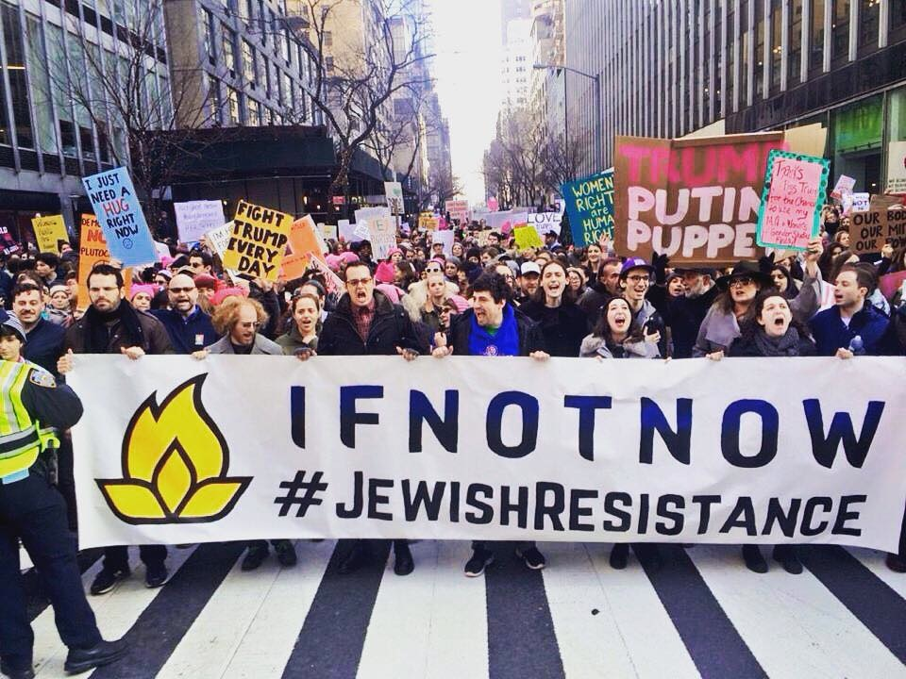

Photo by Gili Getz

Like many American Jews, the only time I’ve been to Israel was on Birthright, a ten-day program meant to build a connection between the State of Israel and Jews in the diaspora. The program is free for participants, who are all Jewish and aged 18-26, and is sponsored by the Israeli government, casino magnate Sheldon Adelson, and others.

Still, it is difficult to overstate the role that the State of Israel plays in American Jewish communal life. My childhood synagogue in Omaha, Nebraska celebrated Israeli Independence Day as if it were our own. We moved to Yardley, Pennsylvania a week before 9/11, and our new synagogue ended weekly services with a prayer for the State of Israel and the Israeli national anthem *Hatikva*, along with a prayer for American troops and the Star-Spangled Banner. And just after I returned from Birthright on a pro-Israel kick, I listened as a member of the Jewish National Fund, which seeks to buy land in the State of Israel for exclusive Jewish control, took the stage to solicit donations during Yom Kippur, the holiest day of the Jewish year. JNF was the same organization that had planted a tree in Israel, on their own land, in honor of my Bar Mitzvah and that of almost every other Jewish child in America.

Growing up in these kinds of spaces, which are the norm in the American Jewish community, makes it extremely difficult for young Jews to be exposed to, let alone understand, critiques of the Israeli government. From around fifth grade onward, my Hebrew School teachers told us that pro-Palestinian reports on CNN and elsewhere were part of a systematic bias against Israel. Religious leaders whom my family trusts have called the Boycott, Divestment, and Sanctions movement a grave and anti-Semitic threat, and have argued that boycotting should be made illegal. I don’t remember ever hearing the word “occupation” until I was well into my twenties.

But like so many others, I came back from Birthright with more questions than answers. In fundamental ways, Birthright “worked” on me: I wept at the Western Wall, and I felt connected to my religion and to the People Israel -- that is, the global community of Jews -- in ways that I never had before. I’d prepared myself for a distinctly nationalist bent ahead of the trip, but I didn’t have the tools to deal with it once I got back home. After a program that puts a heavy emphasis on being fruitful and multiplying, and that has long been rumored to pay for weddings or honeymoons between participants, I was unsure if I should even stay with my Catholic girlfriend.

So I began reading everything I could about Judaism and progressive politics, looking for signs that I could hold both at the same time. I read about the Yiddish labor organizers of the Lower East Side in the early twentieth century, who had fled pogroms in Europe and sought to build a more just world in America. I read about Abraham Joshua Heschel and the 1960s Jewish activists, some observant but most not, who participated as allies in the Freedom Rides and other Civil Rights actions. And I read about Jewish Renewal, a contemporary religious movement that breathes life into Jewish ritual through lenses including feminism, Kabbalah, music, and, sometimes, radical politics.

Renewal rabbis and writers, including Michael Lerner, Lynn Gottlieb, Arthur Waskow, and Judith Plaskow, have taught me that a fetishization of the Israeli government is not the only means of affirming a Jewish identity. Rabbi Lerner’s notion of Judaism as a religion that connects the political to the natural is a concept that resonates deeply with me. Lerner and others point out that many Jewish holidays celebrate nature and political justice at the same time. Pesach, or Passover, celebrates both our liberation from slavery in Egypt and the fertility of spring. Sukkot celebrates both our wandering towards the Promised Land and the fall harvest. And Shabbat, the central day in Jewish life, combines the natural need for rejuvenation with the distinctly political need to refrain from labor. These insights helped me experience my Judaism in a new and more meaningful way. So, too, did the candidacy of Bernie Sanders, a secular socialist who nonetheless raises the indignant *kvetch*, or complaint, to a spiritual form, and who has inspired a generation of Jews who had been force-fed Joe Lieberman as kids.

These positive, progressive Jewish role models, and the radical spirituality they helped me find, allowed me to understand and confront the injustice that haunts far too many Jewish institutions. Never a loner dependent on pro-Israel nationalism for my identity, I was able to see the occupation for what it was. And last fall, after Bernie was out but Hillary still looked poised to win, I finally felt comfortable pursuing Jewish activism against the occupation. I searched online and found IfNotNow, a movement that seeks to end the Jewish community’s support for the occupation. The first IfNotNow event I attended came days after the election, as white nationalist Steve Bannon was invited to speak to the far-right Zionist Organization of America. IfNotNow, along with movement partners Jewish Voice for Peace and T’ruah, mobilized around 700 people to march through Manhattan in protest, and Bannon never took the stage.

My time in IfNotNow has taught me again and again that Jewish groups with the moral courage to speak against the occupation done in our name have also been some of the first and loudest to speak against anti-Semitism at home. During the Senate confirmation hearings this spring of David Friedman, the ambassador to Israel who called liberal Jewish groups “worse than kapos,” anti-occupation Jews and Muslims risked arrest while mainstream Jewish organizations remained silent. During the spate of attacks on Jewish cemeteries and bomb threats to Jewish Community Centers around the same time, we and our partners mobilized our communities while mainstream nonprofits showed more interest in currying favor with the racist Trump administration. And after neo-Nazis held a rally in Charlottesville that left one counter-protester dead, anti-occupation Jews joined the March to Confront White Supremacy while mainstream organizations refused to call out the administration, yet played on valid Jewish fears in hopes of raising money.

The wider Jewish Resistance movement is a messy and interwoven and beautiful community. Jewish Voice for Peace is a twenty-one-year-old group that embraces the call for BDS and speaks openly about Zionism. IfNotNow strategically does not take a position on BDS or Zionism, as we welcome members from differing points of the spectrum on these charged topics, so long as they are willing to mobilize against the occupation. Jews for Racial and Economic Justice, or JFREJ, fights to dismantle racism and exploitation in New York City, and has created a vibrant community for Jews of color and others. Open Hillel organizes against Hillel International’s policy of excluding groups and individuals on the basis of their position on Israel. And the Jewish Solidarity Caucus of Democratic Socialists of America provides a space for Jewish leftists to build on the energy of the Sanders campaign.

To me, a central strength unifying these groups is that they affirm Jewish spiritual practice while rejecting the nationalist logics of both Israel and the United States. In fact, I often find it easier to relate to Christian, Muslim, and other non-Jewish religious activists than to Jews who experience their religion as a license to exclude others. I believe that the next major step for the Jewish Resistance, and for other spiritual movements that embrace radical politics, is to join the Global Justice movement in its critique of neoliberalism and global capitalism, and in its commitment to creating a new and more just world.

The Global Justice movement had perhaps its most powerful moment at the 1999 WTO meeting in Seattle, as over 40,000 protesters came out in diverse coalitions against destructive so-called “free trade” policies. The movement is led by Global South peoples and activists of color, and helped lay the groundwork for the Occupy and other global movements. If the Jewish Resistance were to come to see itself as part of the Global Justice movement, it would enable Jews to more fully confront issues that sometimes complicate our role as activists -- issues like whiteness and economic privilege. It would enable us to build solidarity with other spiritualities and other languages that speak into life *ha’olam haba*, the world to come. And it would enable us to more fully connect our own liberation to that of all other peoples.

We’re already making these connections, of course. I’m one of the IfNotNow organizers who just hosted the Liberation Sukkah, a temporary and vulnerable structure in New York City that linked the occupation of Gaza and the West Bank to injustices in Charlottesville, Houston, Florida, and elsewhere. The Sukkah was a place to pray and sing and learn and *kvetch* together. It put a special emphasis on the connection between the occupation of Palestine and climate justice in the US, giving voice to the fact that marginalized communities are hit hardest by desertification, hurricanes, and other climate disasters. It affirmed that the biblical flood, echoed in so many other religious traditions, might have been not an otherworldly hallucination but an actual phenomenon that humans felt compelled to etch into our cultural memory, perhaps as a warning. We invite you to join us in bringing radical spirituality to bear on political injustices in the world we share. We would be honored to learn at your feet.

*Jacob Friedman is a history teacher and an organizer in the Jewish Resistance. He lives in Highland Park, NJ, works in Newark and organizes in New York City.*